CRAFTER’S CLUB TUTORIAL 11/1/21

Western Bitless Bosal Bridle

Ride in style with this simple bitless bridle, with a customizable touch of colour round the noseband. This is really easy but effective to made, so give it a go!
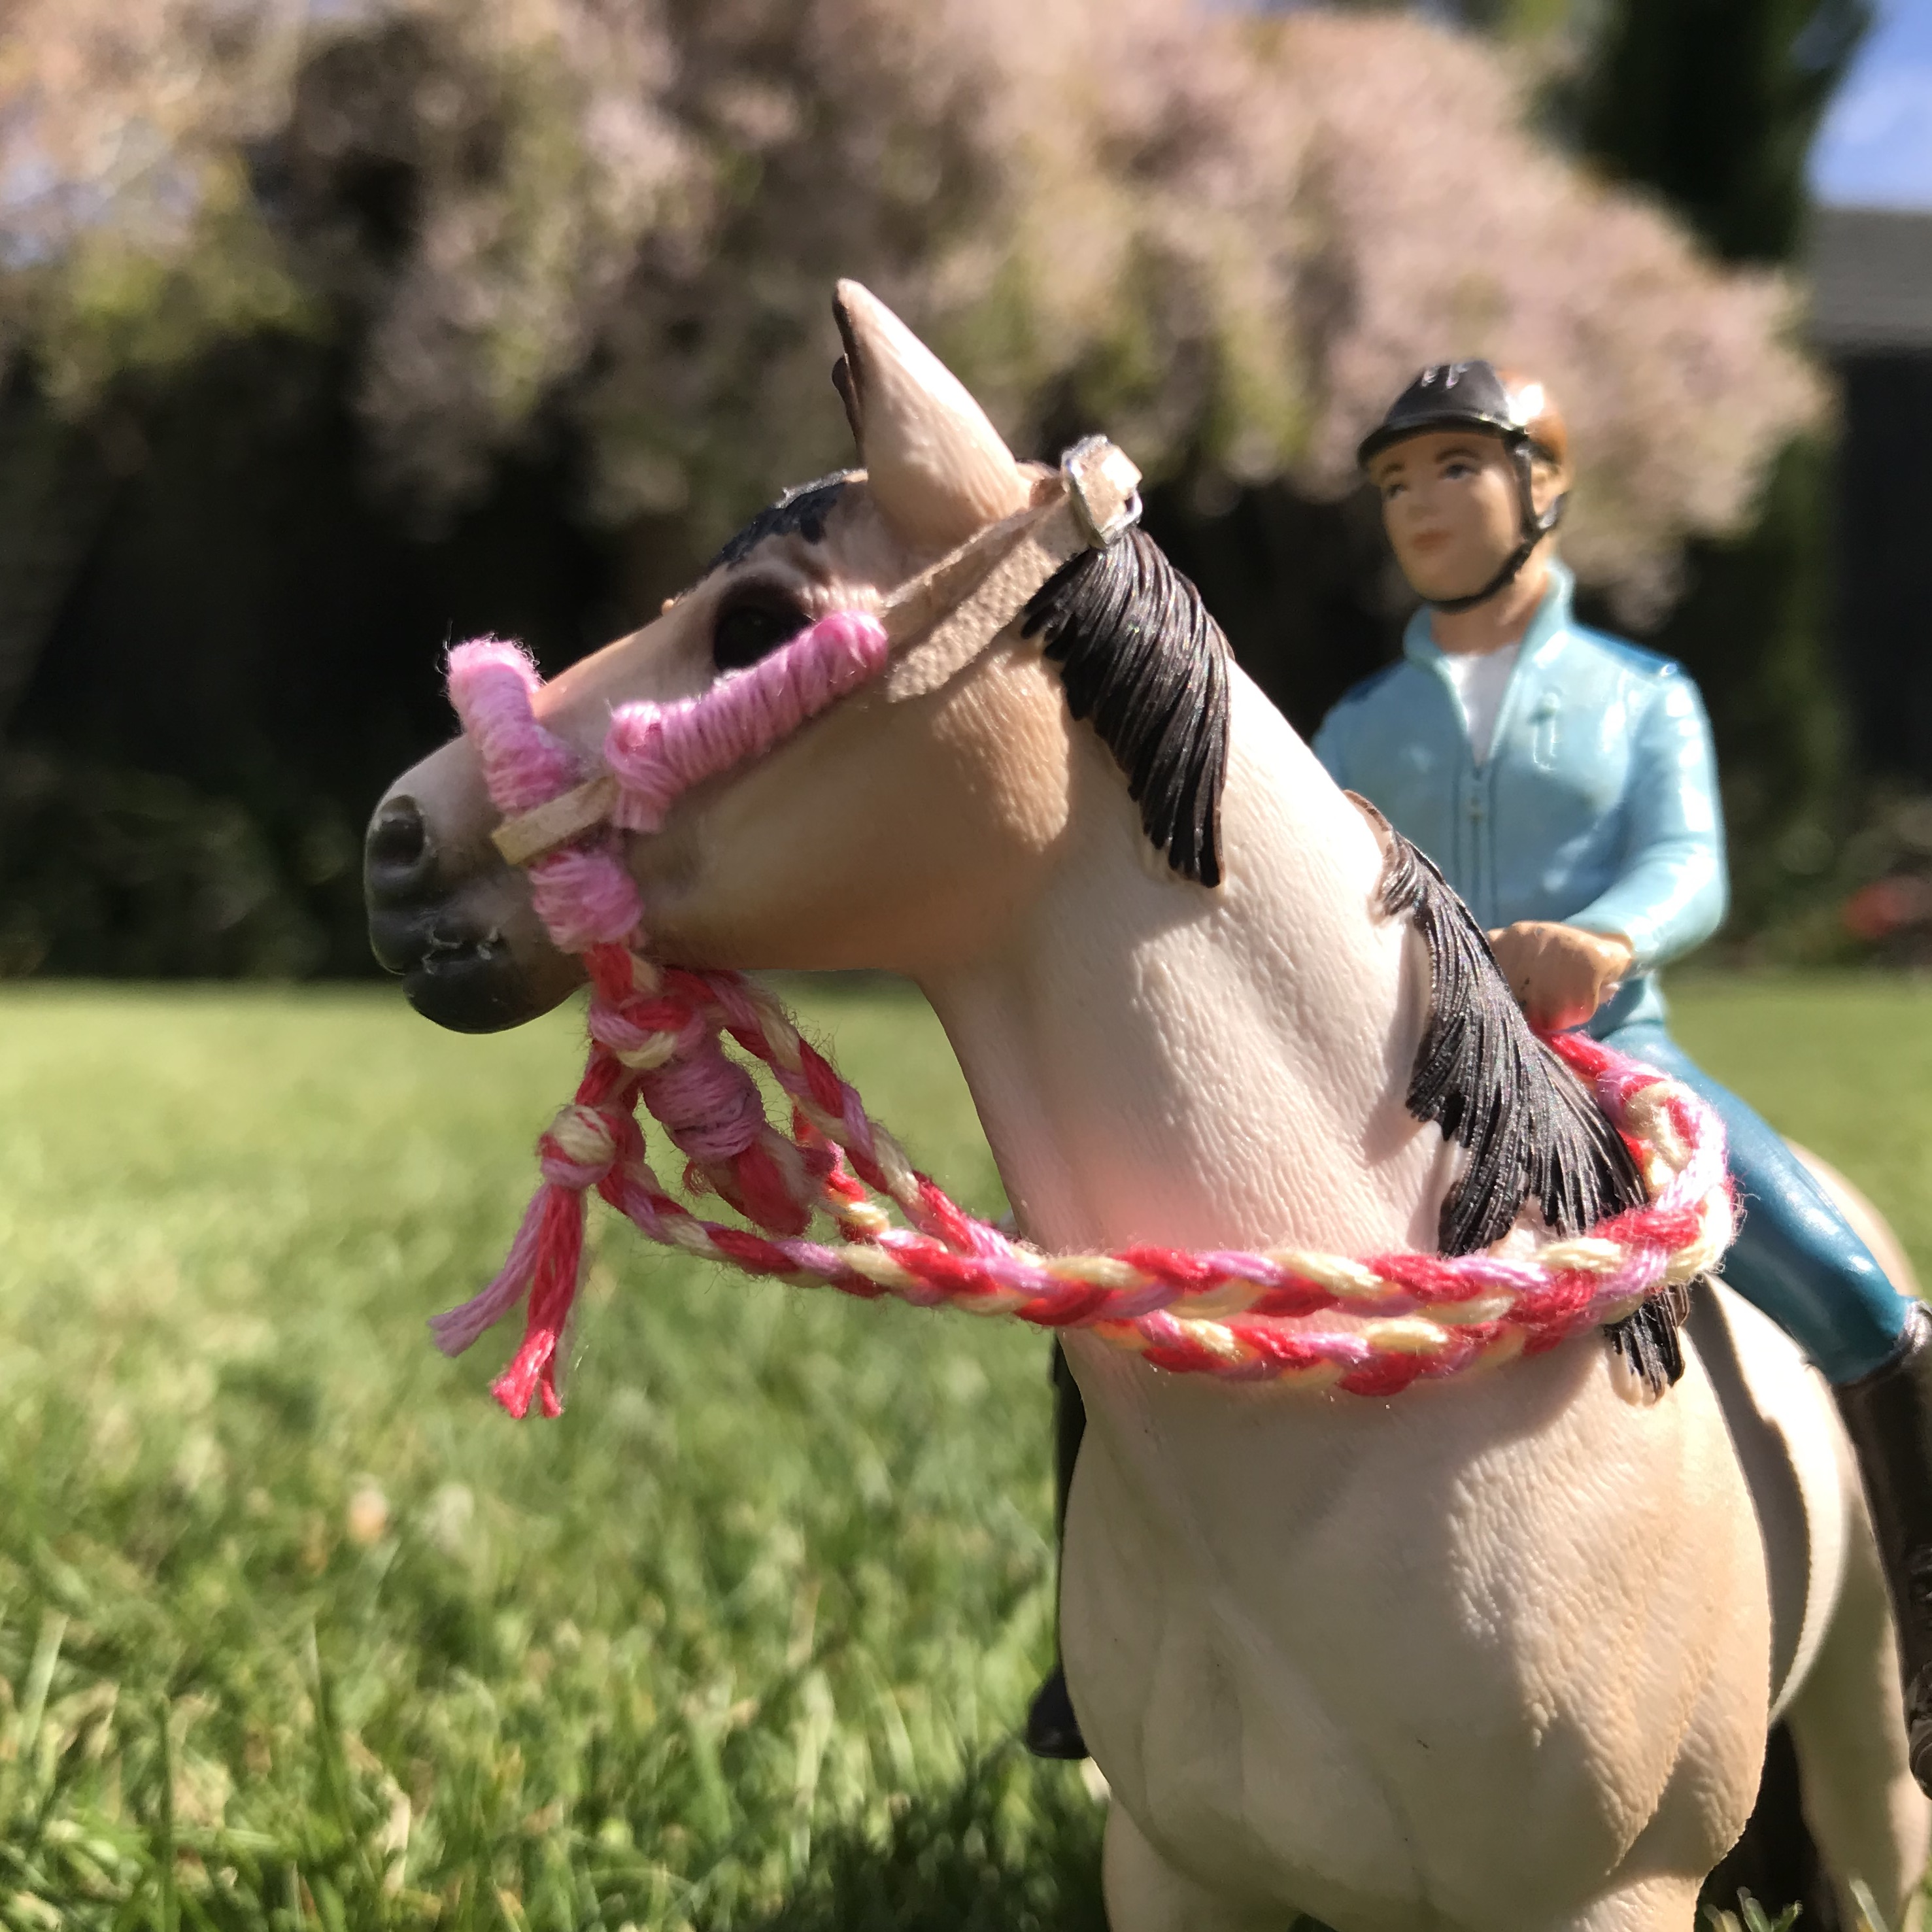
Materials:
-Wire (in normal and extra thin)
-Embroidery thread in 3 different colours
-Leather strapping
-Beads
-Buckle
-Horse for measurements

1. Tie 3 colours of embroidery thread to a 5cm piece of your normal thickness wire, with tails hanging below the wire.
2. Secure the end of the wire and knot to a solid surface (blu tack works well)
3. Plait a 3-strand braid all the way down the wire, making sure to include the wire in the braid.
4. Tie off the braid
5. Bend the wired braid to the shape of your horse’s nose. You are aiming for a shape like this: (kinda like a tennis racket)

6. Wrap the thin wire around the bottom of the tennis racket to hold this shape together.
7. Choose one of your embroidery thread colours and knot it around the 1/4 mark of the tennis racket and wrap it around the noseband, through to the 3/4 mark.
8. Add 2 embroidery thread ‘beads’ a couple of millimetres on each side of the noseband by wrapping the thread around the noseband a couple of times.
9. Cover the wire that is holding your sides together with more embroidery thread, wrapping it around till the wire is covered, and trim the excess off the braid.
9. Place your noseband around your horse’s nose, and cut a strip of your leather strapping, from the noseband to the eye, plus a little extra.
10. Cut a second strip, this time going from the noseband around the ears to the opposite eye.
11. Decorate them with wraps of embroidery thread and beads. These will be your cheek pieces.
12. Wrap one end of the shorter leather strip around the noseband (between the noseband wrap and embroidery buttons) and glue it. Attach a buckle to the other end.
13. Glue the longer strap to the other side (also between the noseband wrap and embroidery thread buttons) to make the full head piece.
14. Done!

PICTURE TUTORIAL

1. 2. 5.
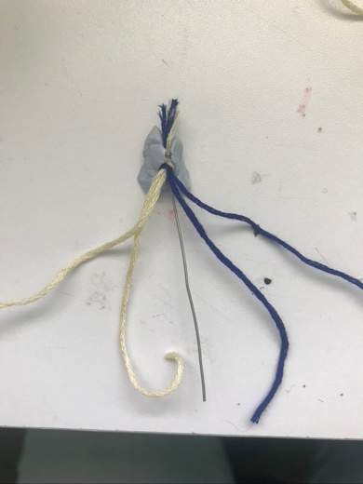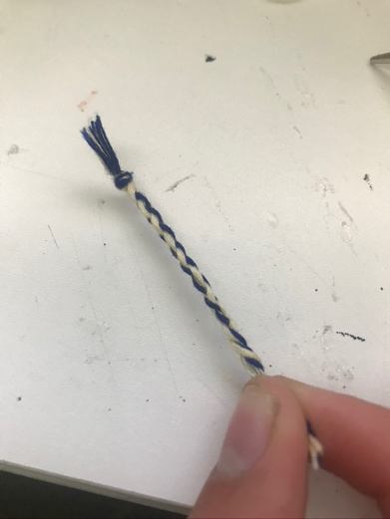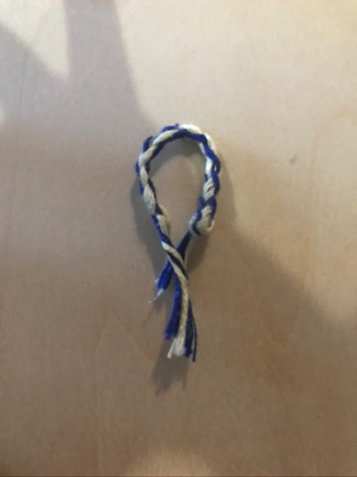

6. 7.
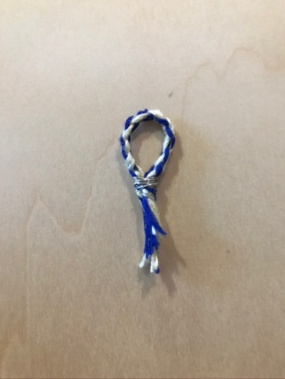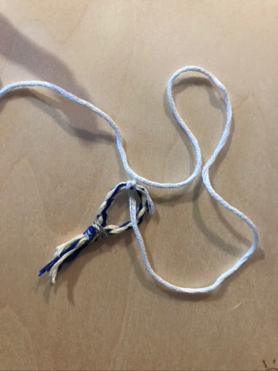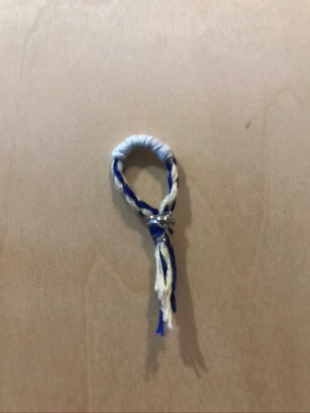

8. 9. 10-13.
