Tack Explained: Rugs
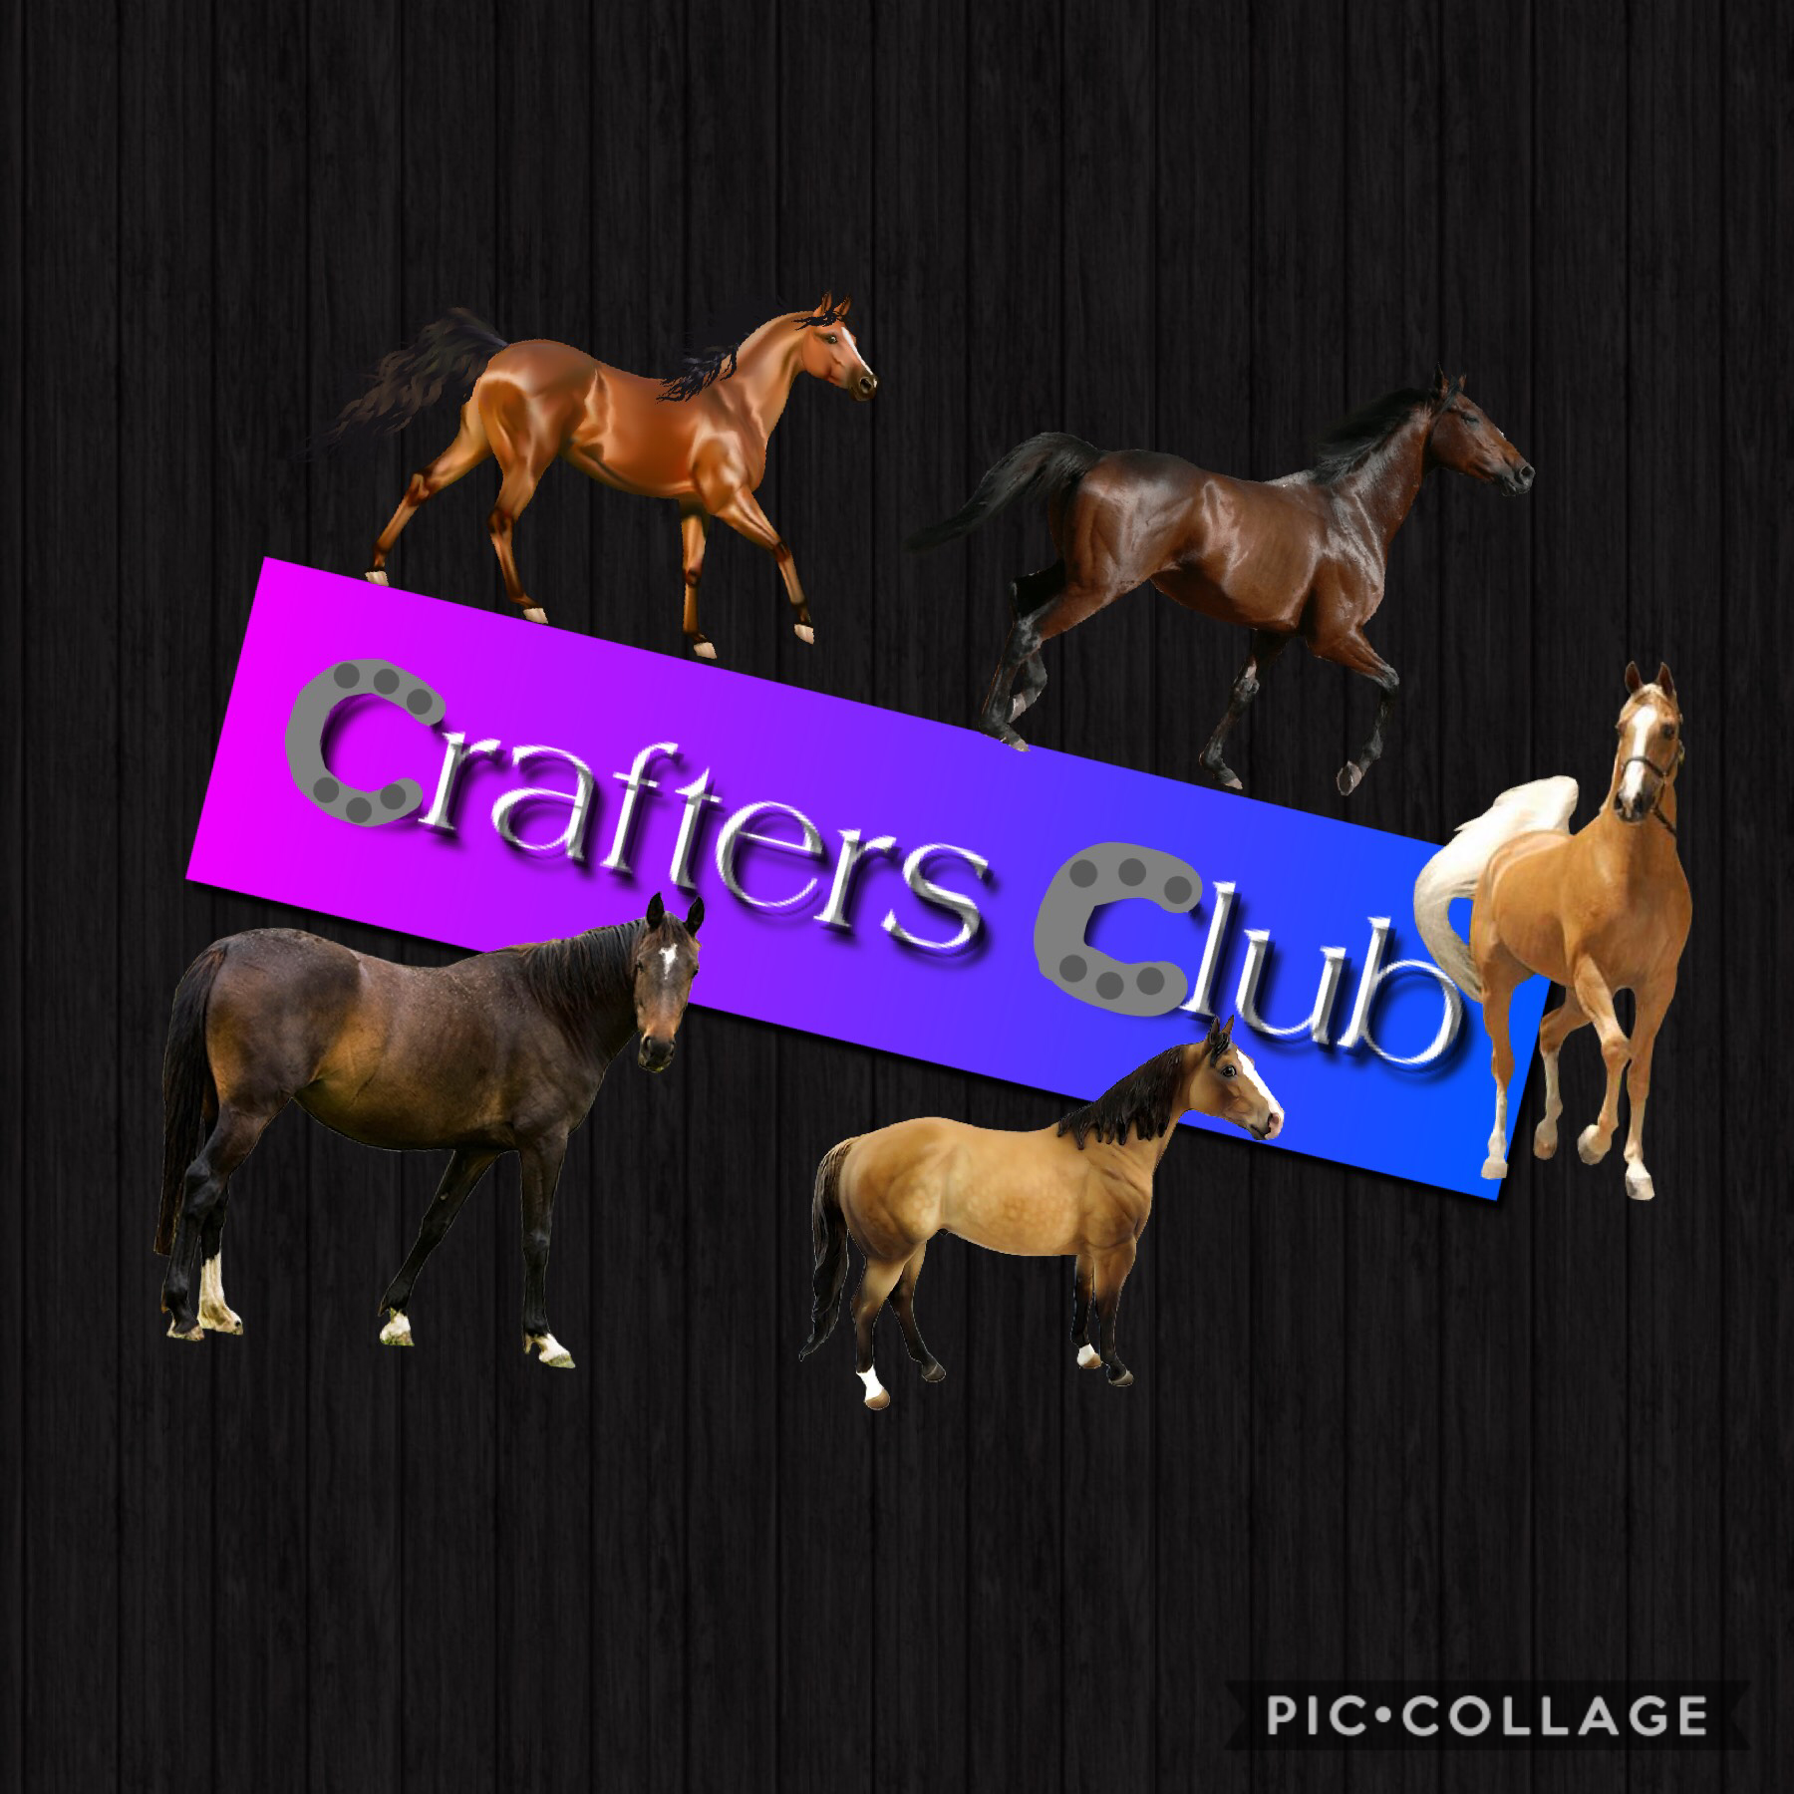

A rug is a very simple, everyday piece of equipment that equestrians use. It is used for keeping the horse warm in the paddock or protecting and keeping him clean before a show. Let’s have a look at the how the rug works, and just a few of the different types of rugs (there’s more than you think ;))

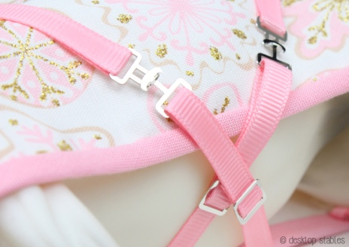
A rug is basically a piece of fabric, with a lining, that is shaped to the horse’s body. It tapers in around the neck, rounds around the shoulders and tapers a little around the tail. Usually, there are 2 belly straps, 2 front straps and 2 leg straps that wrap around the legs and clip onto the rug. These straps are a little hard to explain, so have a look at these >
< pictures for a better idea.
Some rugs have gussest, which are cuts at the bottom of the rugs, with extra fabric underneath to allow for more movement. These are a bit hard to explain, so look at the bottom for some good examples.
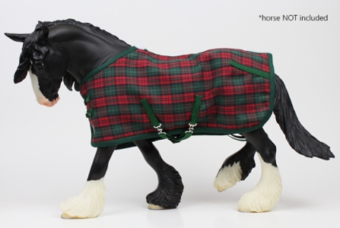
Now, there are many different types of rugs. First, there are just rugs, that are used for keeping the horse warm in the paddock. These usually have a thicker lining to keep the horse warm, and are sometimes quilted (have lines of sewing across them). This type are the ones we usually will be making, and have all the straps listed above.

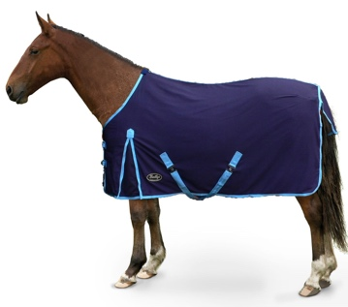
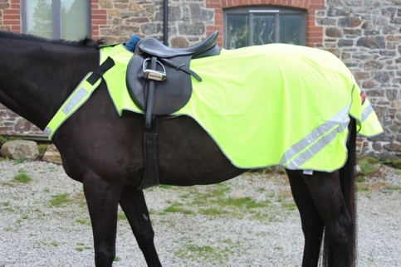
Next, there are sheets. Sheets are lightweight rugs that are used in the paddock on hot days, so have thin material, and possibly no lining. They usually have the same amount of straps as a rug.
There is also another type of sheet, which is not worn in the paddock. Exercise sheets fit under the saddle, like a saddle pad, and keep the horse’s haunches warm during cool morning exercising. These exercise sheets can also come in fluro colours to wear when riding on the road, to increase visibility.

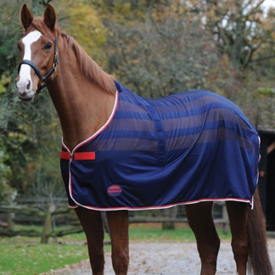
Lastly, there are coolers. Coolers are used after exercise, or after baths, to cool the horse down without letting them freeze, or warm the horse up a little after a bath. These rugs also let moisture evaporate off the horse, so have thin fabric. I wouldn’t add a lining if I was making one of these. Coolers also have less straps. Some don’t have belly straps, or even leg straps.

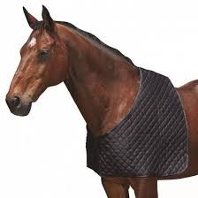
Most rugs also have a tail flap, which is an extra piece of material sewn onto the back of the rug to cover the horse’s tail. Also, on most rugs, you can buy a neck cover which clips onto the rug as an extension, and cover the horse’s neck.

Extra for Experts: Bibs
Some horses need a bib underneath their rug. A bib looks like half a rug, but is made with soft fabric and stops rubs on the horse’s neck and withers.
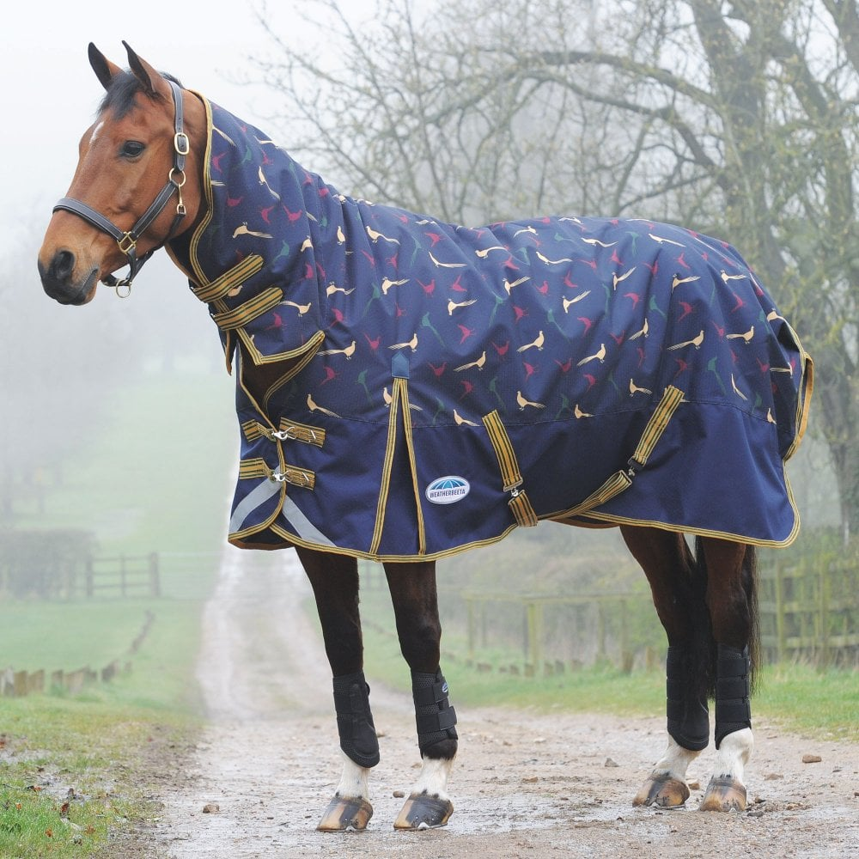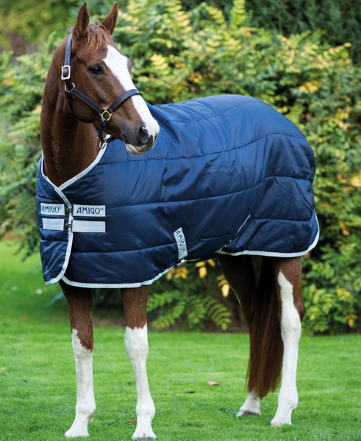
Here’s a rug with a neck cover and gussets, all straps//////And here’s a rug without neck cover, and quilted
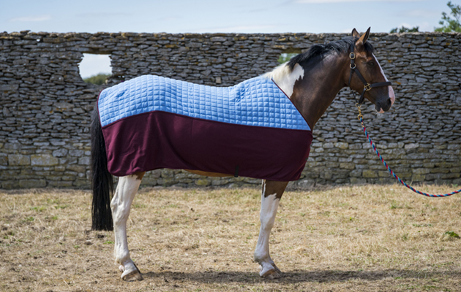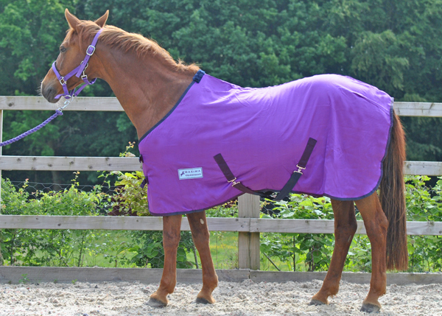
Here’s a cooler, minimal straps, fits well //////////// And here’s a sheet, very similar to a rug but lighter
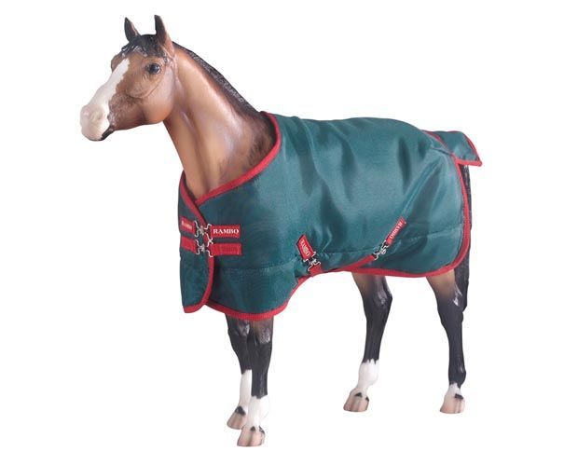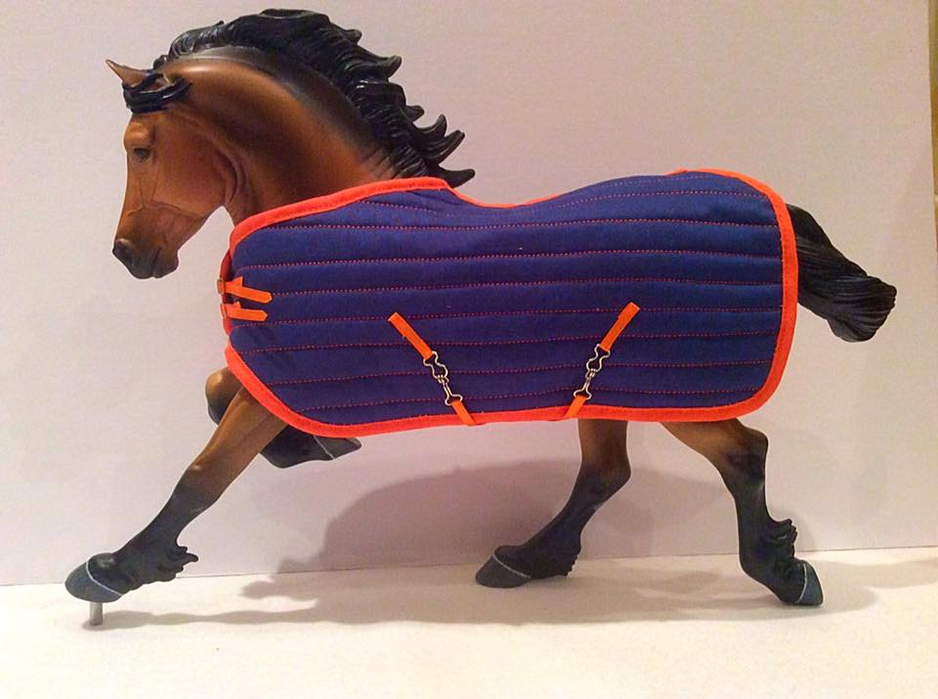
Here’s Breyer’s Rambo rug, nice tail flap ///////// And this one has been fitted to this model, good straps.

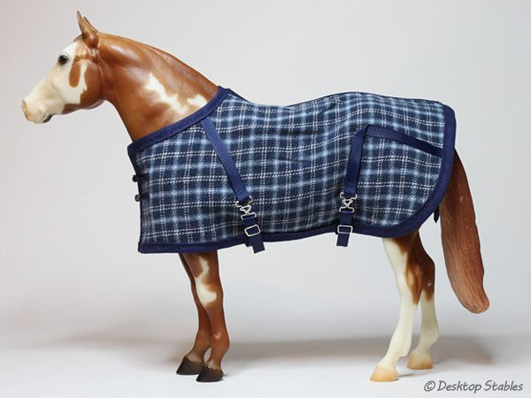
A really nice one by Desktop Stables, just one of many/// Daisy Stall’s blanket, nice and well fitted.
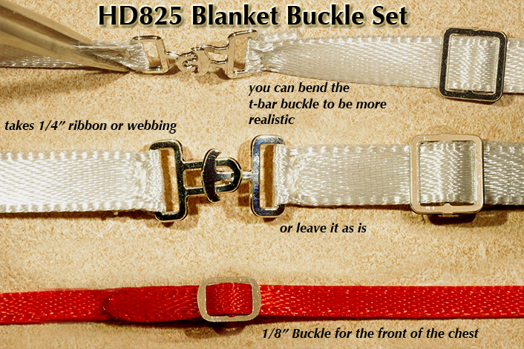
How the straps work

PICTURES
1. & 2. & 3. Desktop Stables
4. https://www.fasttackdirect.co.uk/product/gallop-cotton-summer-sheet/
5. Horse&Hound
6. Redpost Equestrian
7. Equine Superstore
8. https://www.millbryhill.co.uk/equestrian-c4/weatherbeeta-comfitec-plus-dynamic-220g-pheasant-print-combo-turnout-rug-p15720
9. Townfields Saddlers
10. Horse&Hound
11. Maxima Equestrian
12. Hot to Trot Breyers
13. Copperfox Model horses Facebook
14. Desktop Stables
15. Daisy Stalls
16. Rio Rondo Enterprises

© Alice Jordan, Crafter’s Club 2019. (Text, pictures credited) Please do not copy or share without my permission. DO NOT claim as your own.

